EEM Release Notes

for

Version 3.17 released as of

24/08/2018 02:42 PM

Table of Contents

1. Introduction 3

2. Compatible Products 3

3. Installation Steps 3

4. New Features 3

5. Bug Fixes 4

6. Known Problems and Workarounds 4

# Introduction

This document communicates the major new features, bug fixes and setup changes in this release of the EEM. It also documents known problems and workarounds.

# Compatible Products

This release has been tested on the following platforms and products:

* Windows OS 2012 on the Server
* Windows OS 7.0 on the Client
* MS SQL Server 2012
* Internet Explorer 11

# Installation Steps

* Backup the EEM Production Binaries for future use
* Download the Release rar files from the git hub.
* Stop the EEM Production Website on IIS
* Extract any one rar file which will automatically extract all required EEM binaries and related files.
* After successful extraction, copy the files to the EEM release location on the EEM server.
* Go to the Scripts\Upgrade folder in the released location and run Setup.cmd
* Restart the EEM Production Website on IIS

# New Features

**4.1 Feature Description**

Project Plan optimization

**Changes:**

* + The logic for all the project plan slowing is been removed and made the logics to make it faster to avoid latency.
  + Fields where the optimization was done are Initial load, Delete, Repack, Save, Approve, Disapprove

# Bug Fixes

**5.1 Bug Description**

Get rid of thumbs from EEM folders. Though its deleted, it still shows up in EEM folders and files.

**Changes:**

Filtered the system files being shown from EEM.

**5.2 Bug Description**

MSM Status Improvement

**Changes:**

* + To have an interactive and understandable UI we have implemented UI changes in the status of MSM
  + When a user enters a value for today and tomorrow values are taken from a drop down.
  + The plan button is removed where when a user selects plan from the dropdown it shows the users plan for that day.

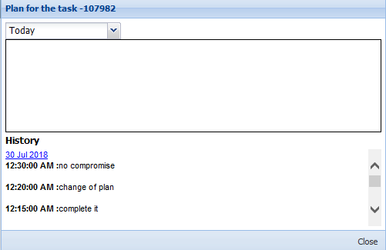

* + History for today and tomorrow will be loaded as of in the writable area which is not editable

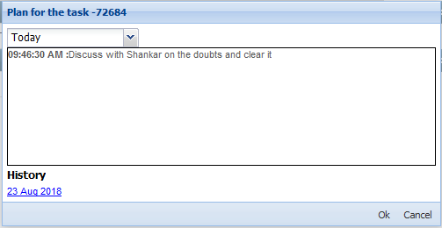

**5.3 Bug Description**

Make the Applets the ability to be plugged in as opposed to be hardcoded.

**Changes:**

A new section in the Framework/web.config is added and from which the Applets will be loaded please do the below highlighted change to make it work

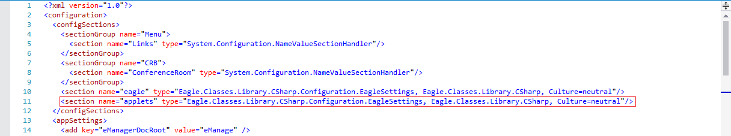

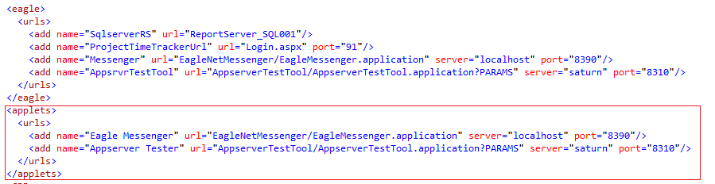

**5.4 Bug Description**

Environmental link -

The local test environments are unavailable for testing when it was accessible from outside, we need to somehow make it work for outside access also

**Changes:**

If a QA or Development environment site is not available or loading, then it disables the link to redirect to that environment.

**5.5 Bug Description**

Fixing Milestone in development stage should check QAP task verification status

**Changes:**

QAP process task verify validation will be done on fixing the development stage task, instead on verifying the development stage.

# Known Problems and Workarounds

None